souvenir from the vanished gallery

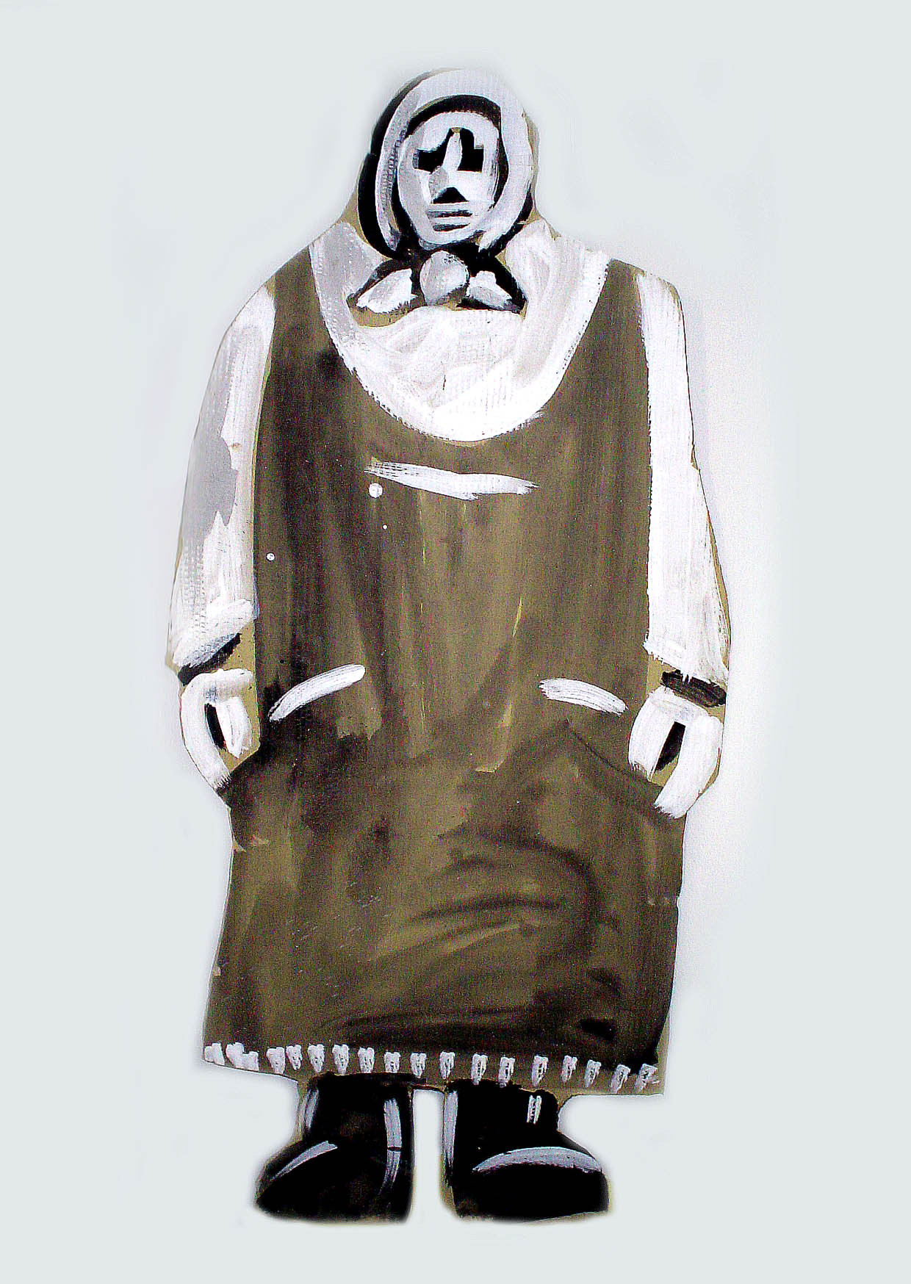
Bring some action! Shoot a picture. Mail it to me: info@van.at
CAUTION! Prepare the picture: JPEG, 400 x 300 pixels, 72 dpi.

Mach was damit! Schieß ein Foto. Mail es mir: info@van.at
ACHTUNG! Das Foto muß dieses Format haben: JPEG, 400 x 300 pixels, 72 dpi.

part of „stormy monday“
http://www.galerie.kultur.at/martin/

